**PYTHON ASSIGNMENT 5**

**1. Make Loading Animation using time module and for loop**

**Code:**

'''

Loading Animation using time module

Author: Amit Dubey

Date: 16-04-2020

'''

import time

print("Python Code for Loading Animation.\nAuthor: Akshay Sorathia\n\n")

print("Loading", end="")

for i in range(0,5):

print(".", end="",flush=True)

time.sleep(1)

**Output:**

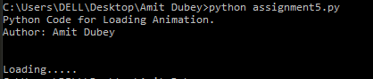

**2. Difference between Return and Yield**

|  |  |
| --- | --- |
| **Yield** | **Return** |
| Yield statement is used to define generators. | Return statement causes a function to exit. |
| It replaces the return value of a function to suspend its execution without destroying the local variables. | It terminates the execution of a function and destroys all the local variables. |
| The yield statement is used when the generator returns an intermediate result to the caller. | The return statement is used when a function is ready to send a value back to its caller. |

**3. Make a digital clock and run it for five seconds.**

**Code:**

'''

Digital Clock in Python

Author: Amit Dubey

Date: 16-04-2020

'''

import time

from datetime import datetime

print("Python Code for Digital Clock.\nAuthor: Amit Dubey\n\n")

for i in range(0,5):

now = datetime.now()

print (now.strftime("%H:%M:%S"), end="", flush=True)

print("\r", end="", flush=True)

time.sleep(1)

**Output:**

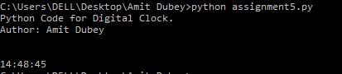

**4. Add anything in tuple**

**Code:**

'''

Adding into tuple

Author: Amit Dubey

Date: 16-04-2020

'''

tup1=(1,2,3,4)

print("Python Code to add an item in Tuple.\nAuthor: Amit Dubey\n\n")

print("The Tuple before adding is: ",tup1)

add=int(input("Enter a number to add into tuple: "))

tup1=list(tup1)

tup1.append(add)

tup1=tuple(tup1)

print("The tuple after addition is: ", end="")

print(tup1)

**Output:**

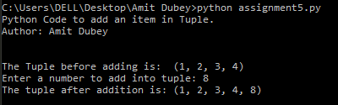

**4. WhatsApp texting using webbrowser lib**

**Code:**

import webbrowser

try:

num=(input("Enter the number you want to send message to: \n"))

message=str(input("Enter your message: \n"))

url=("https://wa.me/"+num+"?text="+message)

# https://api.whatsapp.com/send?phone=917359490589&text=%22Hello%20how%20are%20you%22&source=&data=&app_absent=

webbrowser.open_new_tab(url)

except Exeception as e:

print("Exception caught is %s",e)

**Output:**

